

Name___________________________________________ Date_______________________
Learning to Print the Capitals
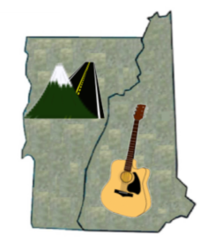 |  | VT = Montpelier, Vermont  NH = Concord, New Hampshire

