

Name___________________________________________ Date_______________________
Writing the 50 States in Cursive
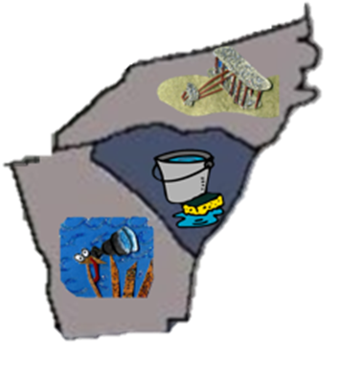 | NC = North Carolina  SC = South Carolina  NC = North Carolina
